CME Group
2020 FIA Test Script

Table of Contents

Important Information 3
Pre-Test Connectivity Certification or “Ping Testing” 6
CME Standard Disaster Recovery Failover 7
Test Date Trade Entry – Globex Pre-Opening 7
Trade Entry and Submission to Hosted Exchanges 8
Clearing Test 8
Communication to CME Group during the Test 10
End of Test 10

Important Information
On Saturday October 24th, the CME Group will be executing a Clearing & Globex DR exercise as part of the annual Futures Industry Association (FIA) DR test. The CME Group test will begin at 9:00am EDT and end at 1:00pm EDT. CME Group represents the merged CME, CBOT, NYMEX/COMEX exchanges; therefore, CME Group will execute one test that includes all entities from the aforementioned exchanges.

Network Description of Production Operations and Outlined Scenarios
During normal operations, all CME Globex and Clearing applications and environments run out of the primary data center. This facility also houses CME Group Co-Location. All global customer connectivity is routed back to this facility via the CME Group network. The disaster recovery facility will be unavailable for any CME Group applications.
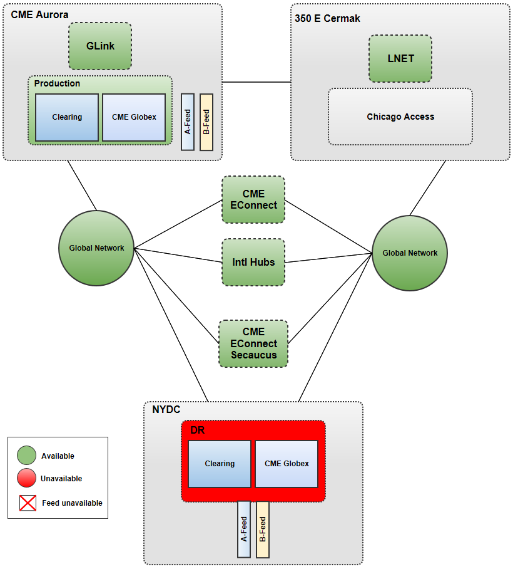

Test Scope: Disaster Recovery Scenarios
The primary Chicago data center houses all CME Group production applications, CME Globex, and Clearing as well as Co-location services. The out-of-region data center houses Disaster Recovery (DR) services and will be accessible via the network depending on the failure scenarios highlighted in the following 2 scenarios. Customers connect to both production and DR applications via the same IP address (MQ) or DNS name (sFTP - sftpng.cmegroup.com)
This topic highlights the potential scenarios that could impact customer connectivity during a disaster in Chicago. In these 2 scenarios, both Clearing and Globex will be available via the disaster recovery facility.
Scenario 1: Regional: Chicago Metropolitan Disaster: All CME Group Chicago area datacenters are down and customers will be re-directed to the disaster recovery facility. Note: GLink and LNET are out of scope in this first scenario, firms submitting test trades during this window would need to utilize their back-up order routing facilities. Customer connectivity that is not dependent on Chicago area data centers will be maintained; there will be no changes required by these customers.
This scenario will run for approximately the first (1) hour of the test window (9am to 10am EDT).
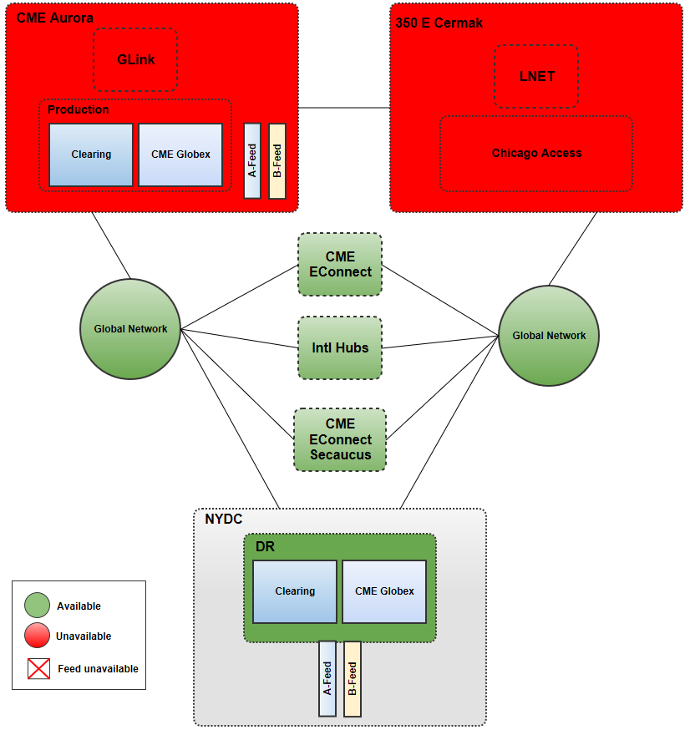

Scenario 2: Primary Data Center Production Room Failure: Co-location Services Available - only the applications and production environment are disabled in the CME Group primary data center. Customers are re-directed to the disaster recovery facility. All method of customer connectivity will be maintained. Note: GLink & LNET have been restored, firms submitting test trades during this window can now utilize their primary order routing facilities. This scenario will run for the last 3 hours of the test window, 10 am to 1 pm EDT.

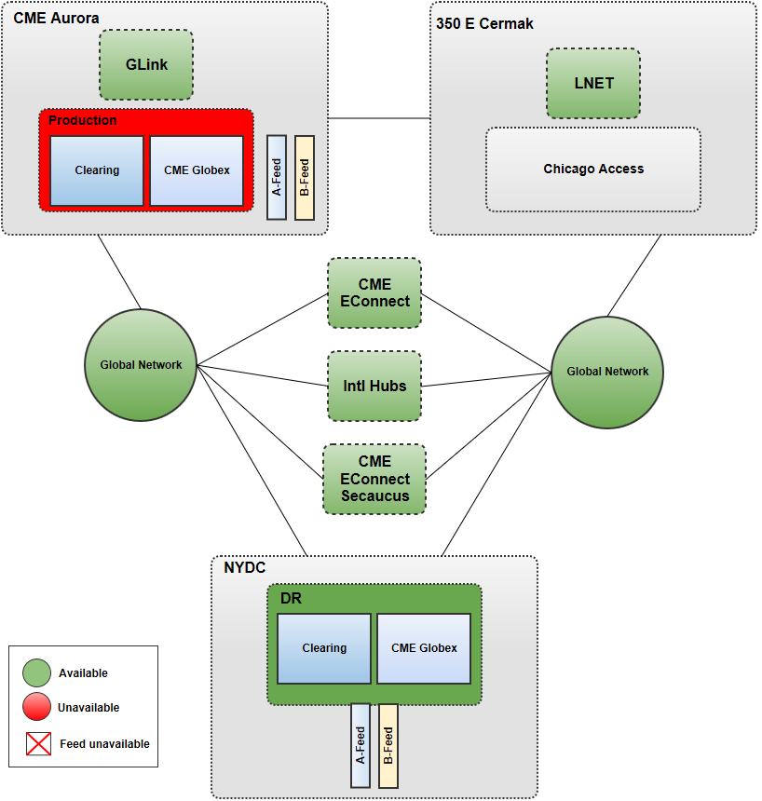

Test Day Support:

- CMEG will fully staff the GCC at our remote site(s)
  - GCC Hotline numbers are: U.S. at +1 800 438 8616, in Europe at +44 800 898 013 or in Asia at +65 6532 5010
- The GCC will be used as the main point of contact for all test participants.
- CME Group requests that the Firms call the GCC if they experience any issues attempting to connect front or back end systems.
- Upon completion of the testing, Firms are asked to call the GCC. The GCC staff will record the firm’s completion. Additionally, please complete the FIA Results 2019 form found on the FIA website, or contact the Business Continuity team at BCM@cmegroup.com to obtain a copy. Results and comments will be captured to create an overall results report. As stated in the FIA meetings, no Firms’ names will be used in the report.
Participating firms are encouraged to contact the support team at BCM@cmegroup.com with any questions you may have prior to the test, during the test or following the test.
Detailed information pertaining to the front end Globex trading system and the back-end Clearing system can be found in the associated sections of this document.

Pre-Test Connectivity Certification or “Ping Testing”
Clearing Ping Testing
In preparation for the FIA test, CME Group will hold two mnadatory preliminary MQ Ping tests for member firms on Saturday(s) Aug 29th and Sept 12th 2020 from 8:00 a.m. to 1:00 p.m. (EDT). The purpose of this preliminary testing is to ensure that firms are able to connect from their DR sites to CME Group’s back-up DR site. Please note that the CME Group utilizes a Single IP for firms connectivity to MQ and a Single DNS name (sftpng.cmegroup.com) for firms connectivity to sFTP for production and DR environments. For this test Firms should point their respective DR systems to the normal CME Group Production IP address for MQ or Production DNS name for sFTP and the CME will reroute internally. To obtain/clarify the IP address for MQ or DNS for sFTP used during testing please contact CME client services group at 312-207-2525 or ccs@cmegroup.com.

Preliminary Ping Testing Components
As noted, the CME Group will be utilizing a single IP address for MQ and a single DNS name for sFTP. Clearing Member firms should continue to point to the normal Production IP addresses and DNS name.

There will be two components to this testing, both to be tested on your firms designated pre-test date: TBD per firms registration via FIA website.

- MQ Ping: CME Group and firm staff must complete an MQ ping. No real MQ messages will be sent since we are only testing access to back-up MQ queues and do not want firm messages to be sent to them in error. Firms should make certain that there are NO messages in your outbound (TRADIN) queues before you begin your test. If messages are sent to the CME back-up systems, they cannot be retrieved by CME Group and moved to Production MQ queues; although, firms can certainly resend them.

Network Requirements
Your existing network configuration will remain intact. Firms should point their respective DR systems to the normal CME Group Production MQ IP address and the CME will re-route internally to the CME DR environment.

- sFTP Access: Firms will test their sFTP connection, utilizing the Production DNS name, (sFTP - sftpng.cmegroup.com) on the same pre-test date they designate on the FIA registration form. No DNS name changes are necessary on the firm side and the CME Group will have network support available on both pre-test dates.
- sFTP Access Requirements
To access and utilize CME sFTP services, firms need the following
  - Access to the Internet
  - FTP software that supports SSH/sFTP protocol
  - A CME FTP user ID and password and your CME assigned sFTP directory

NOTE: With the CME Group utilizing a single DNS name architecture, firms can now only pre-test sFTP connections on their designated pre-test day, either Aug 29th or Sept 12th. Please assure your firm has appropriate resources available to complete this portion of the pre-test connectivity. (i.e. Network, MQ etc.…) While confirming connectivity is done on a pre-testing basis, pushing/pulling files to the sFTP servers will only be completed on test day Oct. 24th.

Important: for a complete list of the CME Group IP addresses and port numbers including if your firm’s systems require an IP address to connect to sFTP, please contact CME Clearing House at (312) 207-2525.

Testing Contacts
We ask that you contact the CME Group Clearing Services at (312) 207-2525 or ccs@cmegroup.com to confirm your firm’s participation and register through the FIA website. If you have any questions concerning the test or if you encounter any problems during testing please do not hesitate to contact us.

CME Standard Disaster Recovery Failover
CME Group will failover Globex and Clearing supporting systems per its standard disaster recovery failover procedures. We expect this to be completed by 9:00am EDT on the morning of the test. CME Group will announce when the DR Systems (GLOBEX & Clearing) will be ready and in an Open state on the FIA Conference call.

Test Date Trade Entry – Globex Pre-Opening
On the day of the test, the back-up Globex system will be available; there is no Pre-Opening state on Saturdays. We anticipate that the system should be available at approximately 9:00am EDT that day. CME Group will make an announcement on the FIA Conference call when it is available on test day.

Trade Entry and Submission to Hosted Exchanges
Trades entered into Globex during the exercise will be processed through to the appropriate hosted clearing organization.
Valid Trade date will be October 23rd
Trade Entry – Entering Test Trades into Globex
Enter test trades at the settlement price in the market you choose. Enter about 10 trades. Firms can enter trades utilizing iLink, CME Direct on a Globex product, CME Direct Block trades if applicable to your firm.
Firms may use any market they want. We do recommend that Firms also send orders on Floor Only Contracts if applicable, i.e. SPZ0 that will be listed on GLOBEX for the test.
Firms may receive crossed trades and/or trades with other counterparties.
Trade reporting to firms’ back office systems should be verified and then deleted.

Clearing Test

Component I – Clearing Connectivity:
To execute the test script, please make the following three connectivity implementations. You can gather the necessary information via the CME Group Clearing Services (CCS) team at (312) 207-2525.
- MQ Messaging: Route your channels from your DR systems to the normal CME Production IP address, CME will reroute internally to CME back-up systems.
- sFTP: Firms should continue to point to the Production sFTP DNS name (sftpng.cmegroup.com) and the CME will reroute internally to the back-up site.
- Front End Clearing (FEC): Use the same User ID and Password that you use in the production environment.

Component II – EX-Pit (Block Trade) Entry:
- Log in to the ClearPort or CME Direct application.
- Access the Block Trade Entry screen and enter the following trade and hit the Save button:
  - 5000 EDH1 xxxx.00
- Conduct a Normal Search. Using Search Type Block verify that the trades you entered are in the system.

Component III – PCS, CGM, & Large Trader Reports
- Please FTP the PCS (PCS.CMF_999.xml) CGM (CGM.xxx.01.xml) and Large Trader (PFTP.F999RPS.DATA) files from either Thursday, October 22, 2020 or Friday, October 23, 2020.

Component IV –Trade Register & SPAN File:
- After CME Group receives your PCS , Large Trader, and CGM files, we will make available Thursday’s Trade Registry and the SPAN file.
Trade Register file name: FIXML-xxx_zzz_EOD-yyyyddmm.xml.zip
Where xxx is the firm number, and zzz is the exchange (CME, CBT, NYMEX)
Span file name: cme.s.pa2, cme.s.pa2.zip, cme.c.pa2, cme.c.pa2.zip, cme.date.s.pa2.zip, and cme.date.c.pa2.zip
- After verifying receipt of these files please delete them, revert your systems back to your Production, complete the 2020 results form (available on the FIA website or contact CME to obtain at BCM@cmegroup.com) and then call the GCC (U.S. at +1 800 438 8616, in Europe at +44 800 898 013 or in Asia at +65 6532 5010) to recap the test results.

Communication to CME Group during the Test
Firms have several avenues to contact CMEG staff before, during or after the test. They can contact:
- The BCM team via email using BCM@cmegroup.com or the FIA Conference call which will be open for the duration of test.
- The GCC in the U.S. at +1 800 438 8616, in Europe at +44 800 898 013 or in Asia at +65 6532 5010.
- The CME Group Clearing Customer Support (CCS) team at (312) 207-2525.

End of Test
Upon test completion firms should contact the GCC at U.S. at +1 800 438 8616, in Europe at +44 207 623 4747 or in Asia at +65 6532 5010 acknowledging test completion, and then complete/submit the test questionnaire posted on the FIA website to recap the test results.

